LAUNCH INFORMATION

JV Page
Product Name | AragonMax AI
Affiliate Network | Launchpad
Launch Start Date | Wednesday, 7th of October @ 11am EST
Launch End Date | Thursday, 13th of October @ 11:59pm EST
Launchpad Affiliate Link
Sales Page Preview(still tweaking)
VSL
Review Access | TBA
Swipes
Bonuses
Coupon Code
Support Desk | https://creatorosai.tawk.help/

What Is ArgonMAX AI?
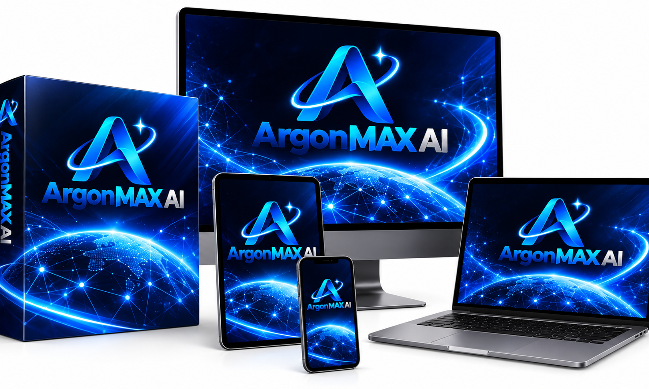

The World's First AI Dashboard That Turns One Login Into A Complete AI Content Team
Write unlimited blogs, ads, emails & code, powered by Gemini Argon AI, Without Paying $200/Month For A Dozen Different AI Tools… One Dashboard, One-Time Price, Results In Seconds.

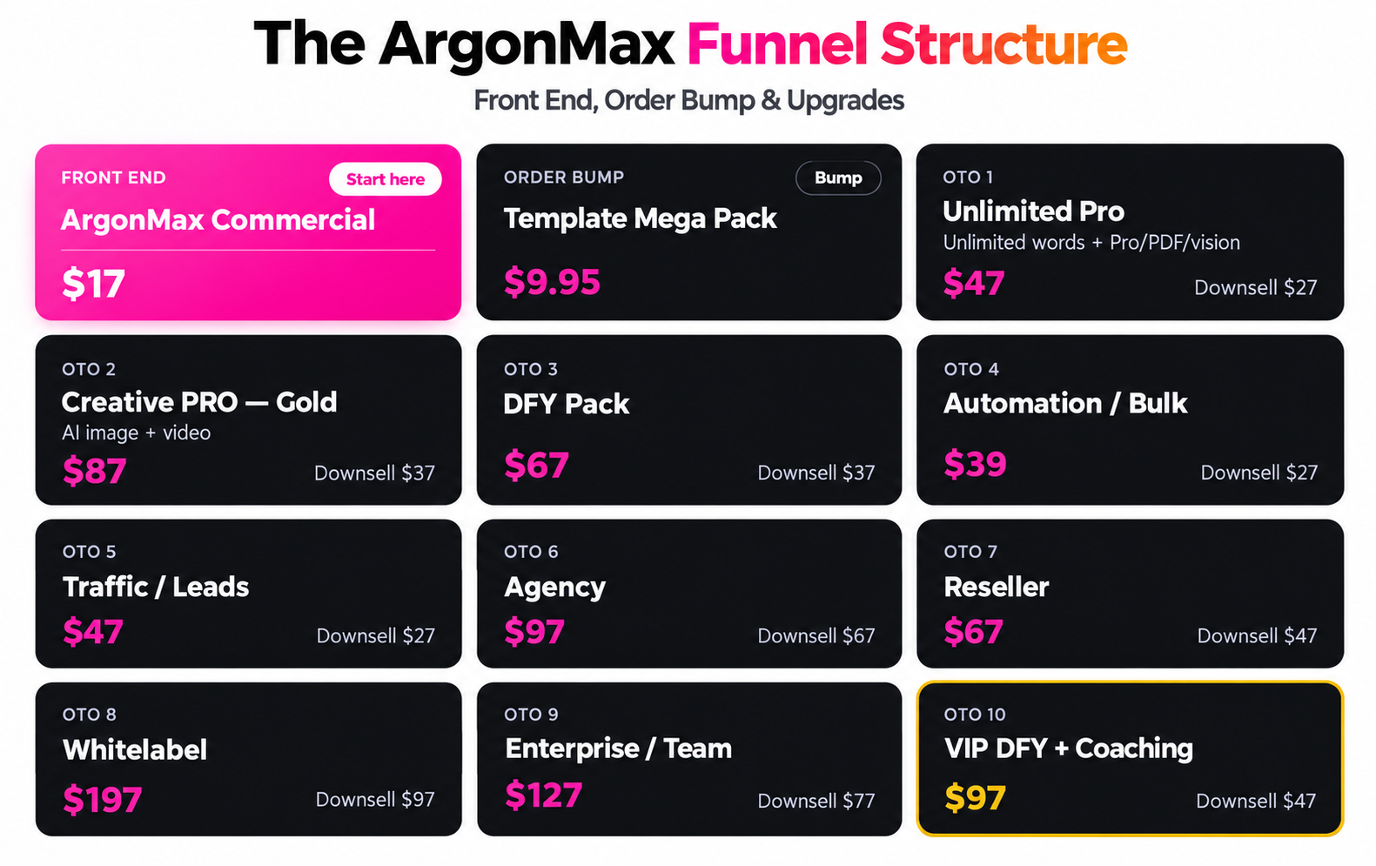
Cash Prizes
All Contests Are Based On Total Revenue - Solo Only!


*Important: You need to earn an equal to or more amount of commissions in order to qualify for the full prize money. If you don’t, then you’ll be paid out the next leaderboard position's amount. In any situation, in order to win a cash prize, one has to earn an equal amount of affiliate commissions.

Thanks For Your Support, Contact Me If You Need Anything.

MEET THE FOUNDERS
Meet the team behind ArgonMAX AI
Product strategy meets AI engineering. Two dedicated minds, one mission: helping creators and businesses bring their ideas to life.
  Pradip  Product Strategist  Leads the product vision, strategy and customer-focused innovation behind ArgonMAX AI.  EXPERTISE  Product Planning · Marketing Strategy · Funnel Optimization  Connect with Pradip on Facebook |  |   Prem  AI System Engineer  Builds the AI systems powering ArgonMAX AI, with advanced automation and intelligent workflows.  EXPERTISE  AI Development · Machine Learning · Software Architecture  Connect with Prem on Facebook
Together, we are building a simpler way to create with AI.

